Right Parallelepiped

Definition
# Source: AI Source: Provided by: [Data Path: Persons Table -> ID Column: 1, Name_En Column: Motasem Essam] -> From: [ChatGPT] on [7/25/2026]
A right parallelepiped is a three-dimensional polyhedron with six parallelogram-shaped faces in which the lateral edges are perpendicular to the two parallel base faces.
Its four lateral faces are rectangles, while its two bases are congruent and parallel parallelograms.
Unlike an oblique parallelepiped, its lateral edges meet the base planes at right angles.

Simple Definition
# Source: AI Source: Provided by: [Data Path: Persons Table -> ID Column: 1, Name_En Column: Motasem Essam] -> From: [ChatGPT] on [7/25/2026]
A right parallelepiped is a box-shaped solid with two parallelogram bases and four rectangular side faces, where the side edges are perpendicular to the bases.
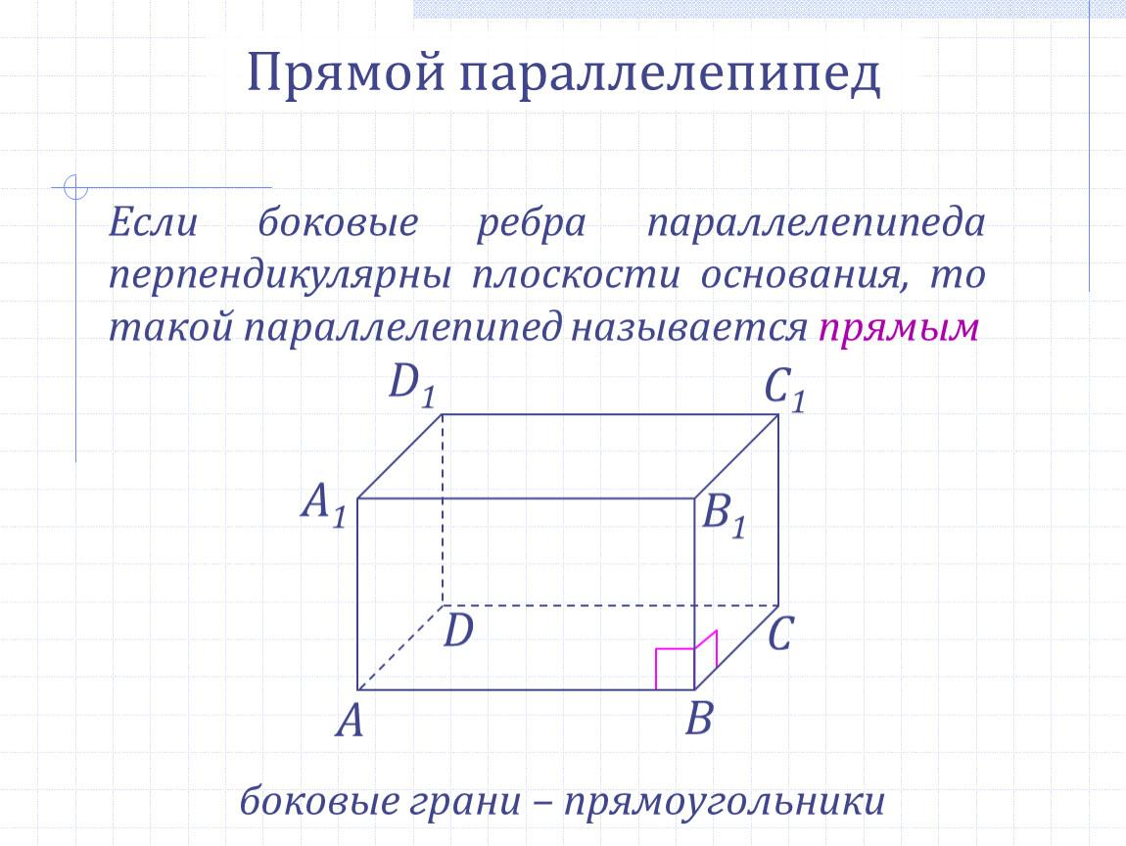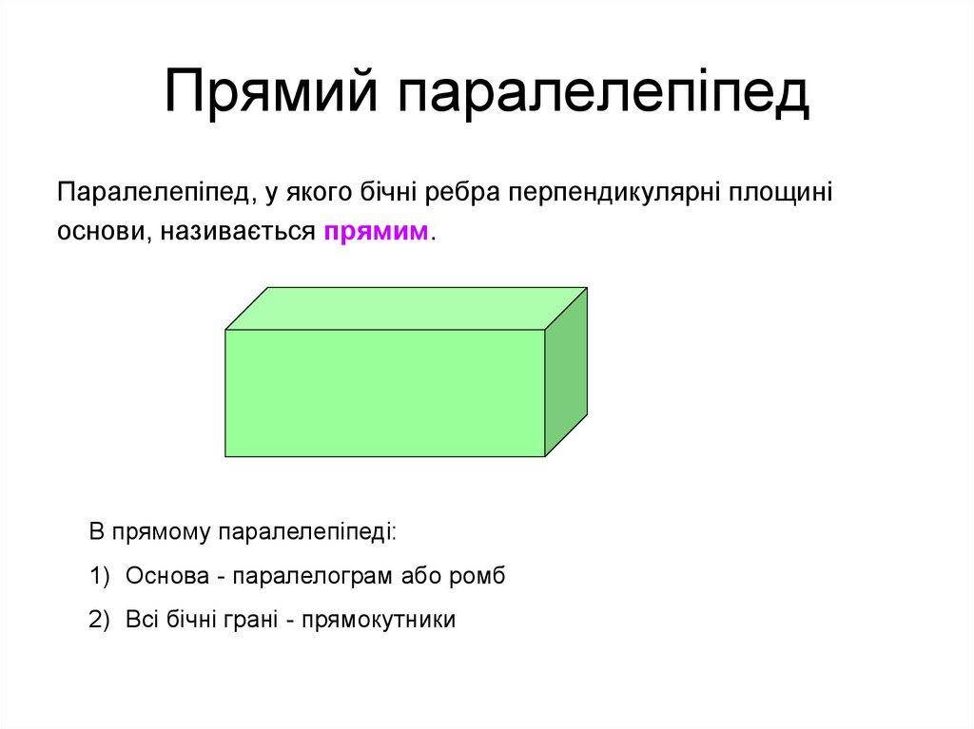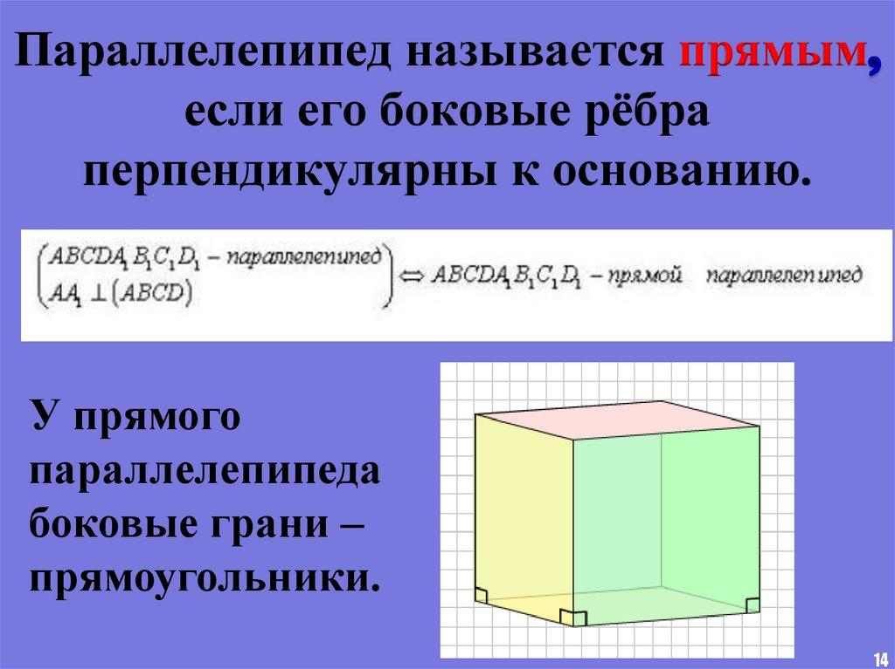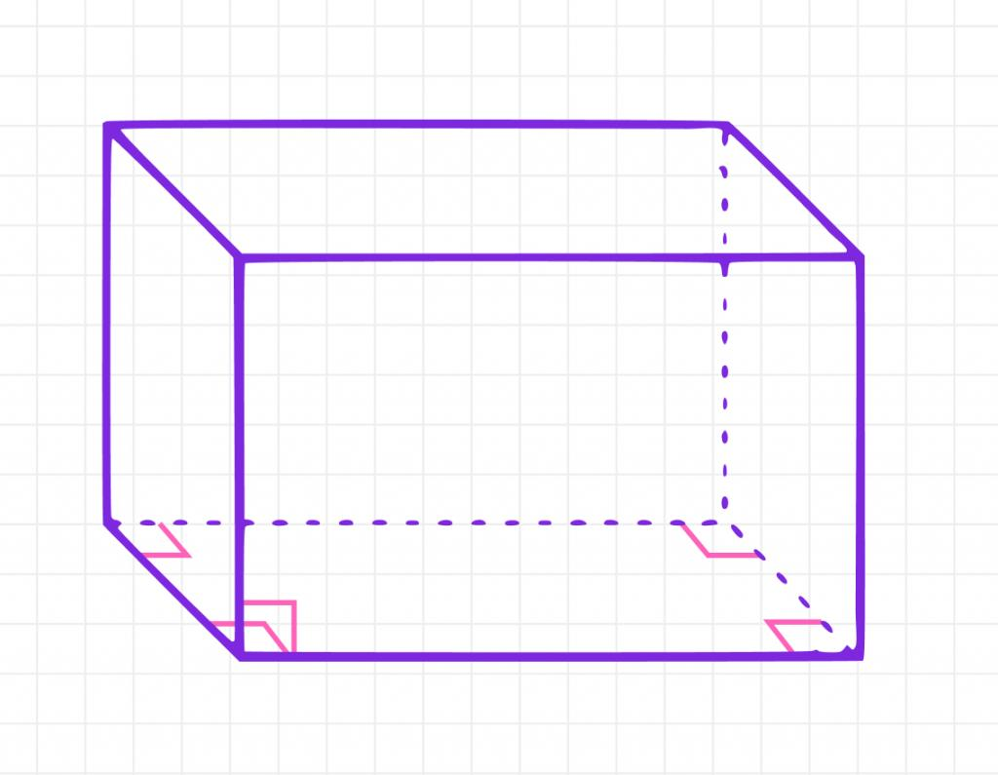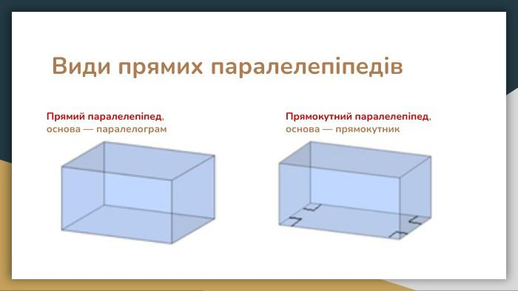

Geometric Structure
# Source: AI Source: Provided by: [Data Path: Persons Table -> ID Column: 1, Name_En Column: Motasem Essam] -> From: [ChatGPT] on [7/25/2026]
A right parallelepiped has the following geometric elements:
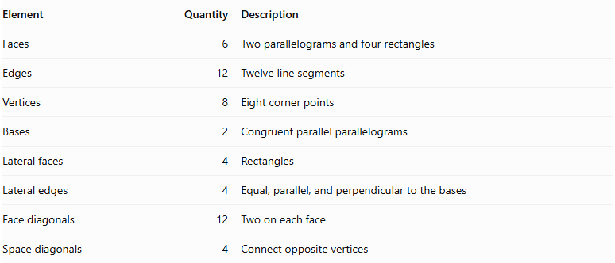
Element | Quantity | Description
Faces | 6 | Two parallelograms and four rectangles
Edges | 12 | Twelve line segments
Vertices | 8 | Eight corner points
Bases | 2 | Congruent parallel parallelograms
Lateral faces | 4 | Rectangles
Lateral edges | 4 | Equal, parallel, and perpendicular to the bases
Face diagonals | 12 | Two on each face
Space diagonals | 4 | Connect opposite vertices

Bases
# Source: AI Source: Provided by: [Data Path: Persons Table -> ID Column: 1, Name_En Column: Motasem Essam] -> From: [ChatGPT] on [7/25/2026]
The two bases are congruent, parallel parallelograms.
Let:
- $a$ = length of the first base edge.
- $b$ = length of the second base edge.
- $θ$ = included angle between the base edges.
The base area is:
$$\boxed{A_{b}=absinθ}$$

Lateral Faces
# Source: AI Source: Provided by: [Data Path: Persons Table -> ID Column: 1, Name_En Column: Motasem Essam] -> From: [ChatGPT] on [7/25/2026]
The four lateral faces are rectangles because the lateral edges are perpendicular to the base plane.
Their dimensions are determined by the base-edge lengths and the perpendicular height.

Lateral Edges
# Source: AI Source: Provided by: [Data Path: Persons Table -> ID Column: 1, Name_En Column: Motasem Essam] -> From: [ChatGPT] on [7/25/2026]
The four lateral edges:
- Are parallel to one another.
- Have equal lengths.
- Are perpendicular to both base planes.
- Have lengths equal to the perpendicular height.

Height
# Source: AI Source: Provided by: [Data Path: Persons Table -> ID Column: 1, Name_En Column: Motasem Essam] -> From: [ChatGPT] on [7/25/2026]
The height is the perpendicular distance between the two parallel bases.
For a right parallelepiped, the height equals the length of each lateral edge.
$$\boxed{h=c}$$
Where $c$ represents the lateral-edge length.
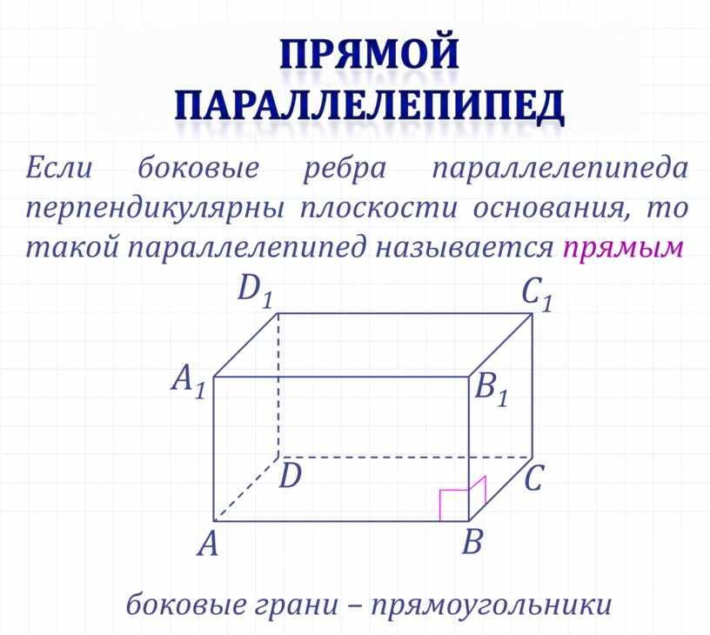

Main Classification of Right Parallelepipeds
# Source: AI Source: Provided by: [Data Path: Persons Table -> ID Column: 1, Name_En Column: Motasem Essam] -> From: [ChatGPT] on [7/25/2026]
Right parallelepipeds can be classified according to the shape of their parallelogram bases.

Rectangular-Base Right Parallelepiped
# Source: AI Source: Provided by: [Data Path: Persons Table -> ID Column: 1, Name_En Column: Motasem Essam] -> From: [ChatGPT] on [7/25/2026]
A rectangular-base right parallelepiped has two rectangular bases and four rectangular lateral faces.
All six faces are rectangles.
Therefore, it is a rectangular parallelepiped (cuboid).
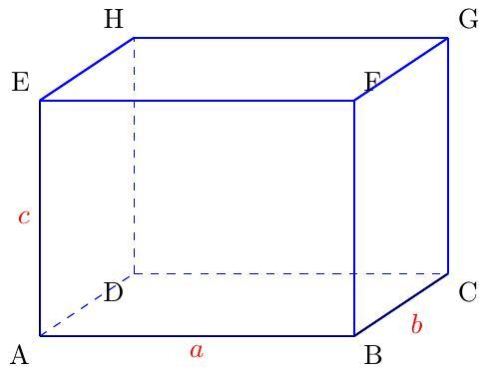
Characteristics:
- Two rectangular bases.
- Four rectangular lateral faces.
- All adjacent faces meet at right angles.
- Three edge directions are mutually perpendicular.

Square-Base Right Parallelepiped
# Source: AI Source: Provided by: [Data Path: Persons Table -> ID Column: 1, Name_En Column: Motasem Essam] -> From: [ChatGPT] on [7/25/2026]
A square-base right parallelepiped has two congruent square bases and four rectangular lateral faces.
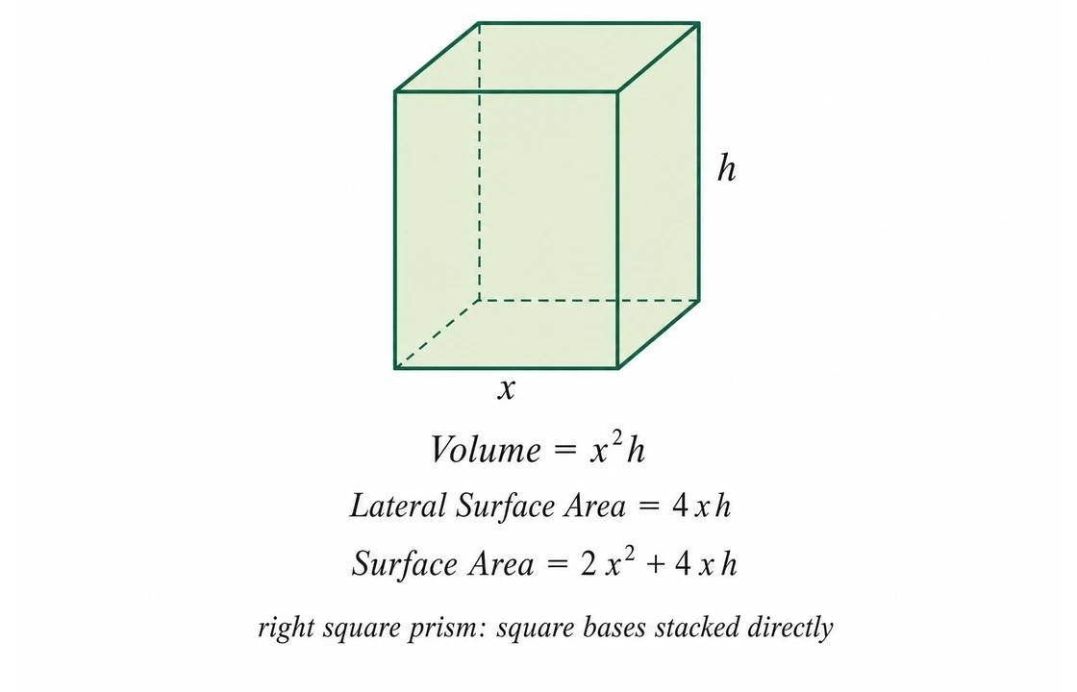
Characteristics:
- Two square bases.
- Four rectangular lateral faces.
- Lateral edges are perpendicular to the bases.
- The base edges are all equal.
- It is a special type of right parallelepiped.
Note: It is also a right square prism. It becomes a cube only when its height equals the side length of its square base.

Rhombus-Base Right Parallelepiped
# Source: AI Source: Provided by: [Data Path: Persons Table -> ID Column: 1, Name_En Column: Motasem Essam] -> From: [ChatGPT] on [7/25/2026]
A rhombus-base right parallelepiped has two congruent rhombus bases and four rectangular lateral faces.
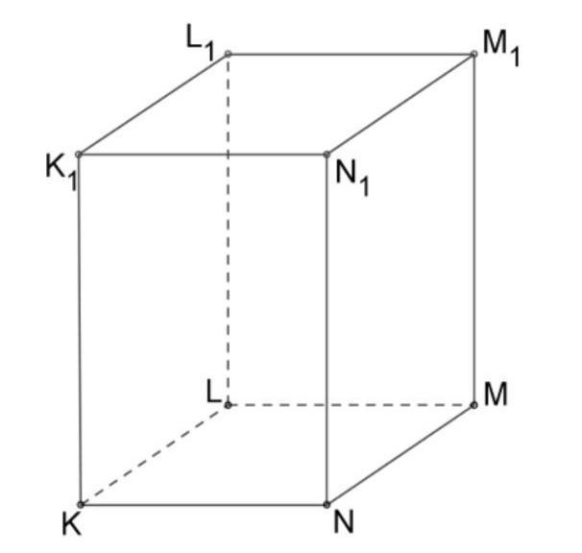
Characteristics:
- Two congruent rhombus bases.
- Four rectangular lateral faces.
- All four base edges have equal lengths.
- Lateral edges are perpendicular to the bases.
- Base angles are not necessarily ${90}^{∘}$.

General Parallelogram-Base Right Parallelepiped
# Source: AI Source: Provided by: [Data Path: Persons Table -> ID Column: 1, Name_En Column: Motasem Essam] -> From: [ChatGPT] on [7/25/2026]
A general parallelogram-base right parallelepiped has two congruent general parallelogram bases and four rectangular lateral faces.
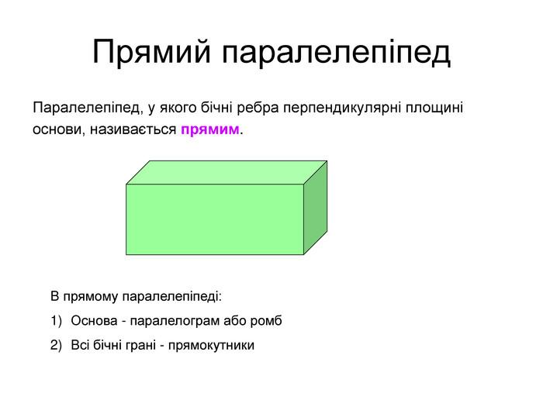
Characteristics:
- Two congruent parallelogram bases.
- Four rectangular lateral faces.
- Adjacent base edges may have different lengths.
- Base angles are not necessarily right angles.
- Lateral edges are perpendicular to the base plane.

Classification by Base Geometry
# Source: AI Source: Provided by: [Data Path: Persons Table -> ID Column: 1, Name_En Column: Motasem Essam] -> From: [ChatGPT] on [7/25/2026]
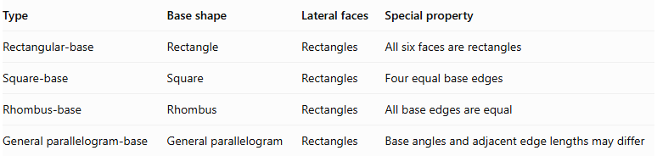
Type | Base shape | Lateral faces | Special property
Rectangular-base | Rectangle | Rectangles | All six faces are rectangles
Square-base | Square | Rectangles | Four equal base edges
Rhombus-base | Rhombus | Rectangles | All base edges are equal
General parallelogram-base | General parallelogram | Rectangles | Base angles and adjacent edge lengths may differ

Mathematical Properties and Formulas
# Source: AI Source: Provided by: [Data Path: Persons Table -> ID Column: 1, Name_En Column: Motasem Essam] -> From: [ChatGPT] on [7/25/2026]
Let:
- $a$ = first base-edge length.
- $b$ = second base-edge length.
- $h$ = perpendicular height.
- $θ$ = included angle between the base edges.

Base Area
# Source: AI Source: Provided by: [Data Path: Persons Table -> ID Column: 1, Name_En Column: Motasem Essam] -> From: [ChatGPT] on [7/25/2026]
The base is a parallelogram:
$$\boxed{A_{b}=absinθ}$$

Volume
# Source: AI Source: Provided by: [Data Path: Persons Table -> ID Column: 1, Name_En Column: Motasem Essam] -> From: [ChatGPT] on [7/25/2026]
The volume equals the base area multiplied by the perpendicular height.
$$V=A_{bh}$$
Therefore:
$$\boxed{V=abhsinθ}$$

Lateral Surface Area
# Source: AI Source: Provided by: [Data Path: Persons Table -> ID Column: 1, Name_En Column: Motasem Essam] -> From: [ChatGPT] on [7/25/2026]
The four lateral faces are rectangles.
Two have dimensions $a×h$, and two have dimensions $b×h$.
$$LSA=2ah+2bh$$
Therefore:
$$\boxed{LSA=2h(a+b)}$$

Total Surface Area
# Source: AI Source: Provided by: [Data Path: Persons Table -> ID Column: 1, Name_En Column: Motasem Essam] -> From: [ChatGPT] on [7/25/2026]
The total surface area includes the two parallelogram bases and four rectangular lateral faces.
$$SA=2A_{b}+LSA$$
Therefore:
$$\boxed{SA=2absinθ+2h(a+b)}$$

Lateral Edge Length
# Source: AI Source: Provided by: [Data Path: Persons Table -> ID Column: 1, Name_En Column: Motasem Essam] -> From: [ChatGPT] on [7/25/2026]
Since the lateral edges are perpendicular to the base planes:
$$\boxed{c=h}$$

Space Diagonals
# Source: AI Source: Provided by: [Data Path: Persons Table -> ID Column: 1, Name_En Column: Motasem Essam] -> From: [ChatGPT] on [7/25/2026]
A right parallelepiped has four space diagonals.
Let $d_{1}$ and $d_{2}$ represent the two possible space-diagonal lengths, each occurring twice.
The base parallelogram has diagonals:
$$p=\sqrt{a^{2}+b^{2}+2abcosθ}$$
$$q=\sqrt{a^{2}+b^{2}-2abcosθ}$$
The space diagonals are:
$$\boxed{d_{1}=\sqrt{h^{2}+p^{2}}}$$
$$\boxed{d_{2}=\sqrt{h^{2}+q^{2}}}$$
Unlike a rectangular parallelepiped, a general right parallelepiped does not necessarily have four equal space diagonals.

Mathematical Properties of Special Cases

Rectangular Parallelepiped
# Source: AI Source: Provided by: [Data Path: Persons Table -> ID Column: 1, Name_En Column: Motasem Essam] -> From: [ChatGPT] on [7/25/2026]
When the base is a rectangle:
$$θ={90}^{∘}$$
The formulas become:
$$V=abh$$
$$SA=2(ab+ah+bh)$$
$$d=\sqrt{a^{2}+b^{2}+h^{2}}$$

Cube
# Source: AI Source: Provided by: [Data Path: Persons Table -> ID Column: 1, Name_En Column: Motasem Essam] -> From: [ChatGPT] on [7/25/2026]
When the base is a square and the height equals its side length:
$$a=b=h=s$$
The formulas become:
$$V=s^{3}$$
$$SA=6s^{2}$$
$$d=s\sqrt{3}$$

Worked Examples

Example 1: Right Parallelepiped with a Rhombus Base
# Source: AI Source: Provided by: [Data Path: Persons Table -> ID Column: 1, Name_En Column: Motasem Essam] -> From: [ChatGPT] on [7/25/2026]
A right parallelepiped has:
- Base side $a=6$ cm.
- Base side $b=6$ cm.
- Included base angle $θ={60}^{∘}$.
- Height $h=8$ cm.
Find its base area, volume, lateral surface area, and total surface area.
Step 1: Calculate the base area.
$$A_{b}=absinθ$$
$$A_{b}=6×6×sin{60}^{∘}$$
$$A_{b}=36×\frac{\sqrt{3}}{2}$$
$$\boxed{A_{b}=18\sqrt{3}{ cm}^{2}}$$
Step 2: Calculate the volume.
$$V=A_{bh}$$
$$V=18\sqrt{3}×8$$
$$\boxed{V=144\sqrt{3}{ cm}^{3}}$$
$$V≈249.42{ cm}^{3}$$
Step 3: Calculate the lateral surface area.
$$LSA=2h(a+b)$$
$$LSA=2×8(6+6)$$
$$\boxed{LSA=192{ cm}^{2}}$$
Step 4: Calculate the total surface area.
$$SA=2A_{b}+LSA$$
$$SA=2(18\sqrt{3})+192$$
$$\boxed{SA=192+36\sqrt{3}{ cm}^{2}}$$
$$SA≈254.35{ cm}^{2}$$

Example 2: Right Parallelepiped with a General Parallelogram Base
# Source: AI Source: Provided by: [Data Path: Persons Table -> ID Column: 1, Name_En Column: Motasem Essam] -> From: [ChatGPT] on [7/25/2026]
A right parallelepiped has:
- Base edge $a=10$ cm.
- Base edge $b=6$ cm.
- Included base angle $θ={30}^{∘}$.
- Height $h=5$ cm.
Find its volume and total surface area.
Step 1: Calculate the base area.
$$A_{b}=absinθ$$
$$A_{b}=10×6×sin{30}^{∘}$$
$$\boxed{A_{b}=30{ cm}^{2}}$$
Step 2: Calculate the volume.
$$V=A_{bh}$$
$$V=30×5$$
$$\boxed{V=150{ cm}^{3}}$$
Step 3: Calculate the lateral surface area.
$$LSA=2h(a+b)$$
$$LSA=2×5(10+6)$$
$$\boxed{LSA=160{ cm}^{2}}$$
Step 4: Calculate the total surface area.
$$SA=2A_{b}+LSA$$
$$SA=2(30)+160$$
$$\boxed{SA=220{ cm}^{2}}$$

Important Characteristics
# Source: AI Source: Provided by: [Data Path: Persons Table -> ID Column: 1, Name_En Column: Motasem Essam] -> From: [ChatGPT] on [7/25/2026]
- It has six faces, twelve edges, and eight vertices.
- Its two bases are congruent and parallel parallelograms.
- Its four lateral faces are rectangles.
- Its lateral edges are parallel and equal in length.
- Its lateral edges are perpendicular to the base planes.
- Its height equals the length of its lateral edges.
- Its base angles are not necessarily right angles.
- Its volume is the base area multiplied by its height.
- Its space diagonals are not necessarily equal.
- A rectangular parallelepiped is a special type of right parallelepiped.

Comparison with Related Parallelepipeds
# Source: AI Source: Provided by: [Data Path: Persons Table -> ID Column: 1, Name_En Column: Motasem Essam] -> From: [ChatGPT] on [7/25/2026]
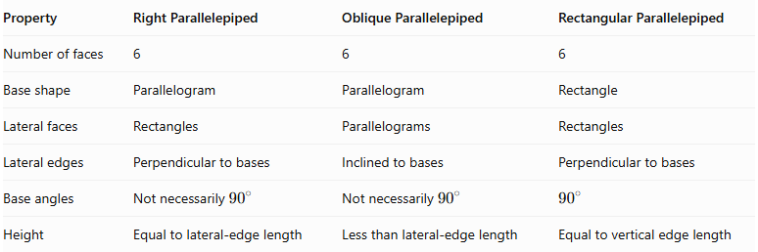
Property | Right Parallelepiped | Oblique Parallelepiped | Rectangular Parallelepiped
Number of faces | 6 | 6 | 6
Base shape | Parallelogram | Parallelogram | Rectangle
Lateral faces | Rectangles | Parallelograms | Rectangles
Lateral edges | Perpendicular to bases | Inclined to bases | Perpendicular to bases
Base angles | Not necessarily ${90}^{∘}$ | Not necessarily ${90}^{∘}$ | $${90}^{∘}$$
Height | Equal to lateral-edge length | Less than lateral-edge length | Equal to vertical edge length
Important distinction: A right parallelepiped does not necessarily have six rectangular faces. Its lateral faces are rectangles, but its bases may be non-rectangular parallelograms.

Constructing Right Parallelepiped in Solid Geometry

Geometric Instruments Used
# Source: AI Source: Provided by: [Data Path: Persons Table -> ID Column: 1, Name_En Column: Motasem Essam] -> From: [ChatGPT] on [7/25/2026]
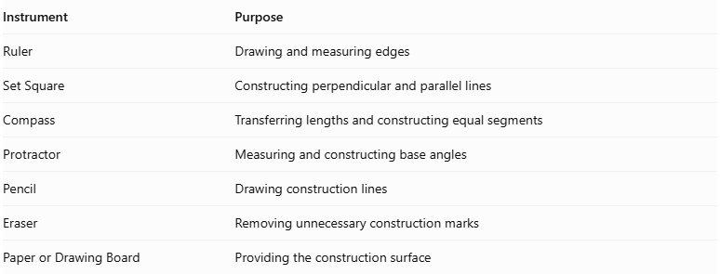
Instrument | Purpose
Ruler | Drawing and measuring edges
Set Square | Constructing perpendicular and parallel lines
Compass | Transferring lengths and constructing equal segments
Protractor | Measuring and constructing base angles
Pencil | Drawing construction lines
Eraser | Removing unnecessary construction marks
Paper or Drawing Board | Providing the construction surface

Instrument-Based Construction Procedures

Isometric Construction
# Source: AI Source: Provided by: [Data Path: Persons Table -> ID Column: 1, Name_En Column: Motasem Essam] -> From: [ChatGPT] on [7/25/2026]
- Draw a parallelogram representing the bottom base.
- From each base vertex, draw an equal vertical edge representing the height.
- Ensure that all four lateral edges are perpendicular to the base plane.
- Connect the upper endpoints to form the top parallelogram.
- Verify that the top and bottom bases are congruent and parallel.
- Complete the six faces and twelve edges.
- Use dashed lines to represent hidden edges when necessary.

Orthographic Construction
# Source: AI Source: Provided by: [Data Path: Persons Table -> ID Column: 1, Name_En Column: Motasem Essam] -> From: [ChatGPT] on [7/25/2026]
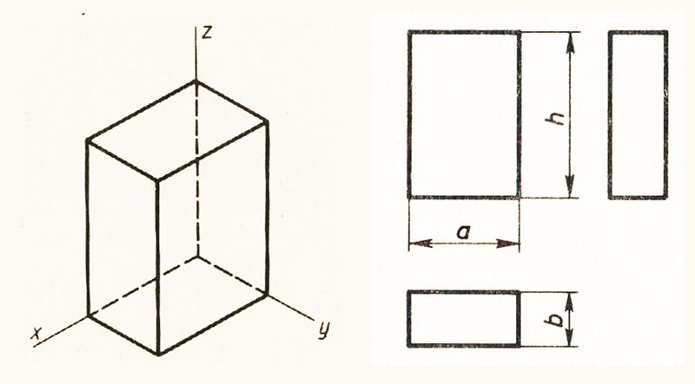
- Draw the top view as a parallelogram representing the base.
- Draw the front view using the appropriate base edge and perpendicular height.
- Draw the side view using the other base edge and the same height.
- Align corresponding edges between the three views.
- Verify that the lateral edges are perpendicular to the base plane.
- Add dimension lines and labels.

Face-Based Construction
# Source: AI Source: Provided by: [Data Path: Persons Table -> ID Column: 1, Name_En Column: Motasem Essam] -> From: [ChatGPT] on [7/25/2026]
- Construct the bottom parallelogram base.
- Construct a congruent parallelogram for the top base.
- Position the two bases parallel to one another.
- Connect corresponding vertices using equal perpendicular lateral edges.
- Complete the four rectangular lateral faces.
- Check parallelism and perpendicularity.

Edge-Based Construction
# Source: AI Source: Provided by: [Data Path: Persons Table -> ID Column: 1, Name_En Column: Motasem Essam] -> From: [ChatGPT] on [7/25/2026]
- Draw the four edges of the bottom parallelogram.
- Construct four equal lateral edges perpendicular to the base.
- Make each lateral edge equal to the required height.
- Connect the upper endpoints to form the top parallelogram.
- Complete the remaining edges and verify the rectangular lateral faces.

Net-Based Construction
# Source: AI Source: Provided by: [Data Path: Persons Table -> ID Column: 1, Name_En Column: Motasem Essam] -> From: [ChatGPT] on [7/25/2026]
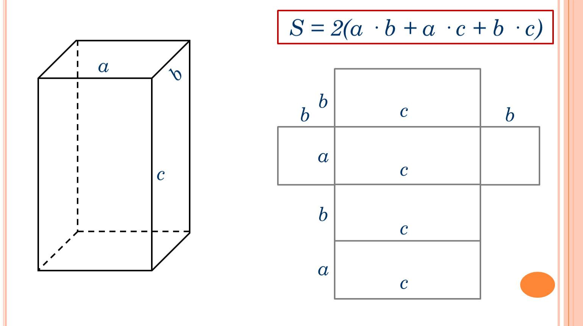
- Draw four rectangles connected in a strip to represent the lateral faces.
- Ensure that the widths of the rectangles match the four edges of the parallelogram base.
- Attach two congruent parallelograms to the appropriate edges to represent the bases.
- Verify that opposite base edges and corresponding lateral dimensions match.
- Add tabs if the net is intended for physical assembly.
- Cut, fold, and join the faces to form the right parallelepiped.

Real-World Applications
# Source: AI Source: Provided by: [Data Path: Persons Table -> ID Column: 1, Name_En Column: Motasem Essam] -> From: [ChatGPT] on [7/25/2026]
Right parallelepipeds are useful in:
- Architecture: Geometric structural models and building components.
- Crystallography: Modeling crystal cells with perpendicular lateral edges and parallelogram bases.
- Engineering: Structural components and mechanical models.
- Mathematics: Studying perpendicularity, volume, surface area, and spatial geometry.
- Computer graphics: Constructing and transforming three-dimensional geometric objects.

Key Points
# Source: AI Source: Provided by: [Data Path: Persons Table -> ID Column: 1, Name_En Column: Motasem Essam] -> From: [ChatGPT] on [7/25/2026]
- A right parallelepiped has six parallelogram faces.
- Its two bases are parallel and congruent.
- Its four lateral faces are rectangles.
- Its lateral edges are perpendicular to the base planes.
- Its height equals the lateral-edge length.
- Its base can be a rectangle, square, rhombus, or general parallelogram.
- Its volume is $V=abhsinθ$.
- Its total surface area is $SA=2absinθ+2h(a+b)$.
- A rectangular parallelepiped is a special case of a right parallelepiped.

Conclusion
# Source: AI Source: Provided by: [Data Path: Persons Table -> ID Column: 1, Name_En Column: Motasem Essam] -> From: [ChatGPT] on [7/25/2026]
A right parallelepiped is a three-dimensional solid characterized by two parallel parallelogram bases and four rectangular lateral faces. Its defining property is that its lateral edges are perpendicular to the base planes. Depending on the shape of its bases, it can have rectangular, square, rhombus, or general parallelogram bases. It provides an important connection between parallelepipeds and right prisms.

